**AGGREGATION SCRIPT EXECUTION**

**Scripts Involved:**

dialssh@hn0-dialma:~/dev$ pwd

**/home/dialssh/dev**

dialssh@hn0-dialma:~/dev$ ls -ltr

total 32

-rw-rw-r-- 1 dialssh dialssh 480 Oct 23 20:49 1_ext_table_mno_data_ddl.sql

-rw-rw-r-- 1 dialssh dialssh 449 Oct 23 20:53 3_global_a2p_bulk_sms.sql

-rw-rw-r-- 1 dialssh dialssh 354 Oct 23 21:02 5_mno_daily_agg.sql

-rw-rw-r-- 1 dialssh dialssh 336 Oct 23 21:13 2_mngd_table_mno_data_ddl.sql

-rw-rw-r-- 1 dialssh dialssh 557 Oct 23 21:21 4_A2P_Filtered_mno_data.sql

-rw-rw-r-- 1 dialssh dialssh 646 Oct 23 21:23 6_mno_month_agg.sql

-rw-rw-r-- 1 dialssh dialssh 0 Oct 24 04:47 3_global_a2p_bulk_sms.csv

-rw-rw-r-- 1 dialssh dialssh 306 Oct 24 05:06 7_first_occrnce.sql

-rw------- 1 dialssh dialssh 97 Oct 24 05:38 nohup.out

**Commands Involved:**

* nohup spark-sql -f /home/dialssh/dev/3_global_a2p_bulk_sms.sql 2> /home/dialssh/logs/3_global_a2p_bulk_sms.log 1>3_global_a2p_bulk_sms.csv &
* nohup hive -i /home/dialssh/dev/4_A2P_Filtered_mno_data.sql &
* nohup spark-sql -f /home/dialssh/dev/5_mno_daily_agg.sql 2> /home/dialssh/logs/5_mno_daily_agg.log 1>5_mno_daily_agg.csv &
* nohup spark-sql -f /home/dialssh/dev/6_mno_month_agg.sql 2> /home/dialssh/logs/6_mno_month_agg.log 1>6_mno_month_agg.csv &
* nohup spark-sql -f /home/dialssh/dev/7_first_occrnce.sql 2> /home/dialssh/logs/7_first_occrnce.log 1>7_first_occrnce.csv &

**Check the logs/execution progress:**

1. For hive query:

dialssh@hn0-dialma:~/dev$ tail nohup.out

1. For spark execution check the log in the log path.

ex: dialssh@hn0-dialma:~/dev$ tail /home/dialssh/logs/3_global_a2p_bulk_sms.log

**Check the application progress via UI:**

1. Login to Ambari :- <https://dialmalawi.azurehdinsight.net/#/main/dashboard/metrics>
2. Click on TEZ View as shown in below snippet

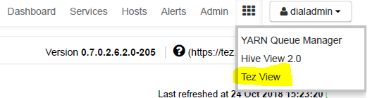

Or access via the link :-<https://dialmalawi.azurehdinsight.net/yarnui/hn/cluster>

1. Locate the query you are executing under hive queries tab of TEZ Home.

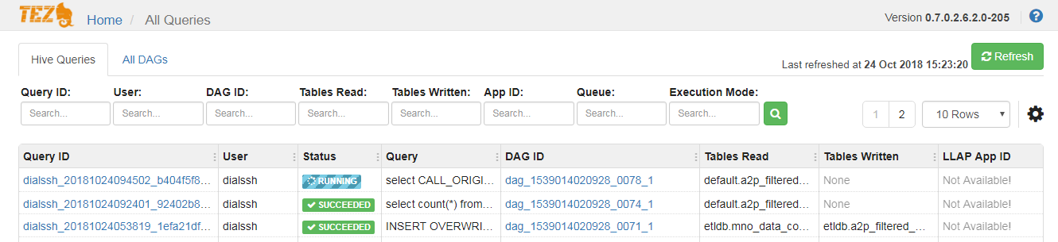

1. Select the DAG_ID corresponding to the query being executed and click on the respective application_id to view the progress of the application



